USIP OSCW Architectural Overview

Introduction 2
A Simulation Page 3
Header Section 3
Simulation Section 4
Main Simulation Objects 4
Architecture Subsystems 6
Network Architecture 6
Simulation Creation Wizard 7
Simulation 7
Simulation Section Creation 8
Base vs. Customized 9
The Base Sim Section Table 11
Persistence 13
User administration 13
Web Cache 13
Auditing 13
Logging 13
Page Updating (Ajax) 13
Alerting system 14
Exporting/Importing 15
Defining Simulation Sections 15
Inverse-APIs Needed 16
Communicating with Simulation Sections 16
Appendix A Design Considerations and Phased Development 18
Design Considerations 18
Phased Development 18

Introduction
This document seeks to provide a basic understanding of the working of USIP OSP to help developers and integrators quickly get up to speed with its use. Its assumed that anyone reading this document has a basic understanding of what the OSP does and looks like to someone at either the player, facilitator or author levels.

To understand the basic objects involved in creating a simulation, it is helpful to first start by looking at what a basic simulation page is and what object it contains. From this basic understanding we then move to specific sub-systems of the tool and the major objects and processes contained in each. A simulation has many parts: it has the part that maintains user information, a part that maintains the basic scenario information, a part that maintains how particular players have performed, a part that manages communication from the server to the client where the player is working, etc. We will walk through all of these sub-systems.

Finally, we discuss how we will be facilitating the integration of third party tools. There is a wealth of free software out there, and we would be foolish to ignore it. But integrating software is never easy. To take as much advantage as possible of the ‘open source software revolution’, we will do whatever we can to spell out how we can work with other people’s products.

A Simulation Page
A basic simulation page is shown in Figure 1. It has two components: a header section and simulation section.
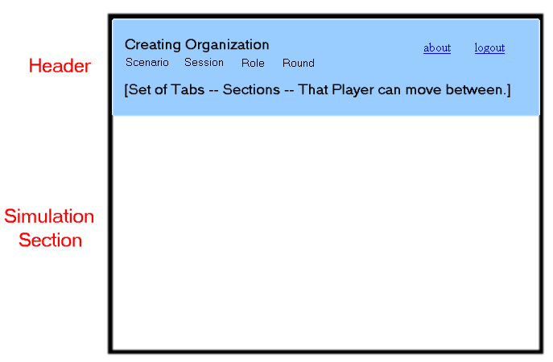
Figure 1. A Basic Simulation Page.

Header Section
The header section (shown in blue) contains basic information that locates the player in the simulation: the name of the organization that created the simulation, what the scenario is, which simulation session is in play, what role they are playing, etc. It also contains a list, shown to them as a set of tabs, of all of the different simulation sections they can enter.

The list of simulation sections available to the player will depend upon 1.) What role they are playing and 2.) What phase the simulation is in. For example, a simulation may be given two phases, ‘Started’ and ‘Completed.’ In the ‘Started’ phase a player may be able to go to simulation sections and take actions. But in the ‘Completed’ phase, the player may be only able to look at what happened.

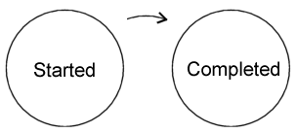
Figure 2. The simplest possible simulation wil have at least 2 phases.

Simulation Section
Simulation sections are shown below the header section. A section can be thought of as one particular web page where the actor can see or do something. Actually a simulation section is precisely a web page: ‘frames’ are used to divide up the entire web page into two parts. The top frame is the header section and the bottom frame is the simulation section. This web page can be on the same server that is hosting the simulation, but it does not have to be.

Since a ‘simulation section’ can either be on the same host as the simulation or on a completely different host, defining them must specify where the section is located. We will discuss ‘section definitions’ later. Also, since sections can be on different hosts, the communication to the particular sections is handled special. We will also discuss that later.

Main Simulation Objects
Shown in Figure 3 are four of the main simulation objects. In the center top is a simulation itself. This contains all of the basic information of a simulation. A simulation can contain many actors (and actors can belong to multiple simulations) this is shown with the association between simulations and actors to its left.

A simulation can contain multiple phases. These phases can be as simple as ‘Started’ and ‘Completed’, but can be more varied depending upon what a simulation creator desires. The simulation creator can add any number of phases to a simulation. One of these phases will be somewhat special since it will be the phase the game begins in. (Phases currently don’t have any particular data associated with them, but that is something we may add in the future.)

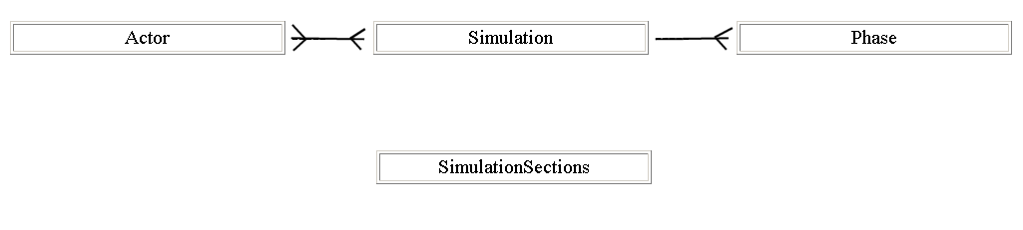
Figure 3. Some of the main simulation objects.

The combination of ‘actor,’ ‘simulation’ and ‘phase’ determine the ‘simulation sections’ that an actor has available to them. These simulation sections are added by the simulation creator, and each one is a web page where the player can do or see something.

Architecture Subsystems

Network Architecture
Client machines will connect to a web server via HTTP or HTTPS. Requests will, in general, consist of a java object (such as a game change) represented in XML.

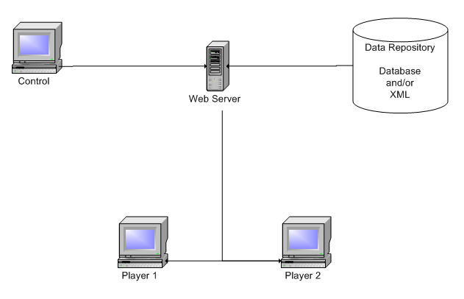
Figure 4. Basic network architecture.

Simulation Creation Wizard
Essentially this is a series of JSP to modify objects contained in a Simulation.
1a.) Actors
1b.) Phases

Simulation
- set of JSPs to allow player to interact with a Running Simulation. Ajax is used to communicate back and forth with the server.

Simulation Section Creation
Creating and maintaining simulations sections is at the heart of this application. One can think of a simulation as nothing more than a group of sections organized by actor and phase. This depiction is shown in Figure 5. The players, playing the role of the actors, see a different set of things they can do in each particular simulation ‘phase.’ Each of these ‘tabs’ is a simulation section.

Sometimes phases may progress naturally toward the finish (1, 2, 3 ...) but they do not need to do so. For example, one phase could represent winter and another summer. So the phases could proceed ‘winter’, ‘summer’, ‘winter’, ‘summer’, and so on until the simulation ends. There is a great deal of flexibility here.

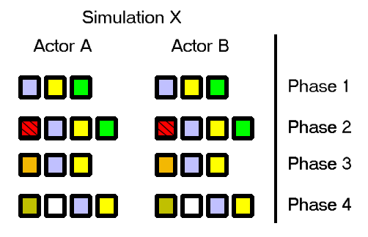
Figure 5. One view of a simulation is just a set of simulation sections organized by actor and phase.

Figure 6 shows a more concrete example of simulation sections. In it, the simulation ‘One Version One’ has two actors assigned to it (Actor 1 and Actor 2) and also has two phases (‘Started’ and ‘Completed’). In phase ‘Started’ the Actor 1 has four simulation sections available to them. The user assigned to the role of Actor 1 can get to each of these sections (Introduction, Your Role, Chat and Actions for 1) by selecting the tab heading for that section.

Continuing with our example, when the simulation transitions into the phase ‘Completed’ the players will have different sections available to them. They will no longer be able to ‘chat’ or take actions. They will only be able to read the ‘After Action Report’ and see the basic information they started the simulation with.

Simulation One Version One
 | Phase ‘Started’ | Phase ‘Completed’
Actor 1 | - Introduction  - Your Role  - Chat  - Actions for 1 | - After Action Report  - Introduction  - Your Role
Actor 2 | - Introduction  - Your Role  - Chat  - Actions for 2 | - After Action Report  - Introduction  - Your Role
Figure 6. The combination of simulation, actor and phase determines the simulation sections.

Base vs. Customized
Some simulation sections are basic to the tool, and do not require any adjustment for use. For example, the ‘Your Role’ page simply shows material that the simulation author has stored in the actor’s background. Every actor sees the material particular to themselves on that page.

But many simulation sections require ‘tweaking.’ For example a ‘News Source’ is not just a ‘News Source.’ It is, to the player, facilitator and simulation author, ‘CNN’ or ‘Al Jezeera’ or whatever. These kinds of tweakings need to be done by the simulation author - while we hide from them the complexity of what they are really dong.

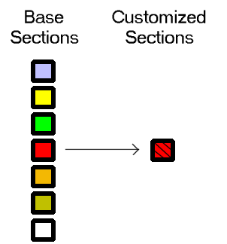
Figure 7. Some Base Sections get Customized by the Simulation Author.

The Base Sim Section Table
Understanding the ‘Base Sim Section’ Table is key to understanding where the basic information on sections is kept. This table contains the following entries:

Type | Source
BaseSimSection | XML File | These are sections that never change. For example, the ‘Introduction Page’ just shows what the simulation author has written. The ‘Cast’ page just shows information on all of the characters. Etc.
CustomizeableSection | XML File | These are archetypal entries that then get tailored to meet the specifics of what a simulation author wants. For example, a ‘Write Document’ page must be tailored to tell the student what kind of document it is that they are writing.
CustomizeableSection’ | Copied from one of the above type of row entries. | These sections have been customized. For example, a ‘Write Document’ section may have been customized to allow the student to ‘Write Memorandum of Understanding’ or ‘Write Constitution.’ Depending on the specifics of the scenario.

a longer exposition on how a section (a tab or web page) is maintained, assigned and shuffled around.

When a simulation author adds a section, they can do it in one of two ways. They can add it to all players in that phase. Or they can add

Set Universal Section
-> Router
-> Make Reflection Page
-> 'Save and Add'
->

Example: Sequence of Events on News Source and News Sink creation.
--------------------------------------------------------------------------

Make News Source
-> Customizable section gets information about the news source (eg. slanted, straight, etc.)
-> Shared Document created (the news)
-> Customizable section given info about the document (its ID) in its contents hashtable.

Make Read News Page
-> Customizable section gets information about the news source (eg. slanted, straight, etc.)
-> Link to the base shared document (the news)
-> Customizable section given info about the document (its ID) in its contents hashtable.

Enable Sim
-> Copy Shared Document object (the news) into a version of this running sim.
-> Update the News Sources linking to this document to point to the version for the running_sim
-> Update the News Pages linking to this document to point to the version for the running_sim

Persistence
a description of how we are using Hibernate to persist objects to multiple database schema.

User administration

- a description of how we are maintaining user information (across multiple schema).

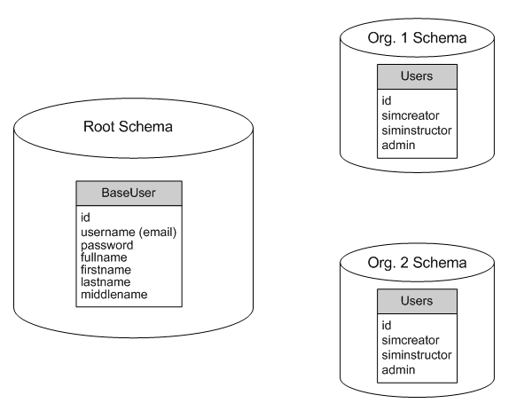

Chat System
Introduction
The Chat system allows players to communicate with each other in both public and private forums.

Client Side

Server Side

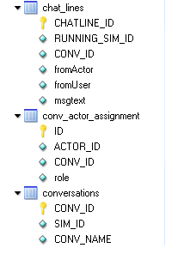

Web Cache
The object org.usip.oscw.networking.USIP_OSCW_ContextListener is used to maintain a web cache of data frequently called from the database.

The caches are stored in hashtables. An example caching hashtable is shown in Figure 8.

Hashtable actor_names = new Hashtable();
context.setAttribute("actor_names", actor_names);
Figure 8. Hashtables stored in the servlet context serve as the caching mechanism.

Auditing

Logging

Page Updating (Ajax)

Alerting system
Alerts are used to notify the players of things they must know immediately. The types of alerts present are declared in the class org.usip.oscw.communications.Alert. The following alert types are defined:

- public static final int TYPE_ANNOUNCEMENT = 1;
- public static final int TYPE_PHASECHANGE = 2;
- public static final int TYPE_NEWS = 3;
- public static final int TYPE_EVENT = 4;

For each running simulation a set of alerts is stored. Some alerts go to all players (such as phase changes and general announcements) others are targeted to specific characters. All are saved in the same list.

There are three types of information associated with an alert:
- A pop-up message may notify the applicable players of the alter.
- A text page (Announcements, Events or a Specific News Page) may contain information on the event
- An email may be sent to the players in some cases, for example for a phase change event.

Exporting/Importing
The open source project XStream is used to turn objects into XML for transport.

There is currently no way to save images.

There is a bug in importing sims – must have a sim to over write on the current database.

Defining Simulation Sections
[insert image of web interface to create simulation sections]

Inverse-APIs Needed
A normal API allows other people to communicate with your program. To take full advantage of the enormous amount of great open source material out there, we want to be able to talk to other people’s programs. So we will need to define a standard way of communicating with our simulation engine, to facilitate the creation of wrappers that we can then use around other people’s code (OPC.)

Communicating with Simulation Sections
Info from Engine to a View
Information sent every time to every page (view) shown in the simulation as part of an HTTP request:
SIM_ID=1&SIM_SESSION_ID&SIM_ACTOR_ID=1&SIM_ROUND_ID

Where the following represent:
SIM_ID Unique identifier of this simulation.
SIM_SESSION_ID Unique identifier of this particular simulation being run.
SIM_ACTOR_ID Unique identifier of this actor in the simulation.
SIM_ROUND_ID The number of this simulation round.

Information from a view (due to user action) back to the Engine
Any application will pass back to the simulation engine this information:
<USIP_OSCW_DATA_PACKET>
<SIM_ID>[1....n]</SIM_ID>
<SIM_SESSION_ID>[1....n]</SIM_SESSION_ID>
<SIM_ACTOR_ID>[1....n]</SIM_ACTOR_ID>
<SIM_ROUND_ID>[1....n]</SIM_ROUND_ID>
<SIM_VAR_LOCAL_MSG_ID>[1....n]</SIM_VAR_LOCAL_MSG_ID>
<SIM_VAR_NAME>[character_string]</SIM_VAR_NAME>
<SIM_VAR_NEW_VALUE>[any]</SIM_VAR_NEW_VALUE>
</USIP_OSCW_DATA_PACKET>

Response sent back to above packet
The simulation engine will pass back the following:
<USIP_OSCW_RESPONSE_PACKET>
<SIM_VAR_LOCAL_MSG_ID>[1....n]</SIM_VAR_LOCAL_MSG_ID>
<SIM_RESPONSE>[accepted|rejected]</SIM_RESPONSE>
<SIM_RESPONSE_ERR_CODE>[1....n]</SIM_RESPONSE_ERR_CODE>
<SIM_RESPONSE_REASON>[optional explanation]</SIM_RESPONSE_REASON>
</USIP_OSCW_RESPONSE_PACKET>

Special Features
A ‘special feature’ is something that may or may not be added to a simulation. For example, some simulations may track specific quantities or values, others may not. Adding a value (such as GDP, or the number of rats in a city) that can be tracked during a simulation is an example of a ‘special feature.’

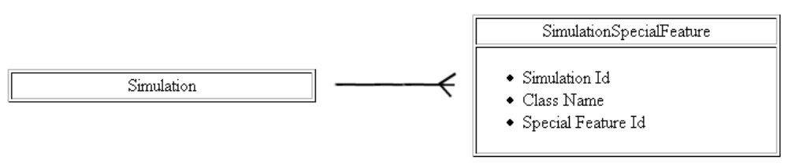
Figure 9. Simulations can have associated with them 'special features.'

An Example Special Feature

Special Features in a Running Simulation
Each special feature added to a simulation will have to get its own unique copy when a specific run of the simulation is being conducted.

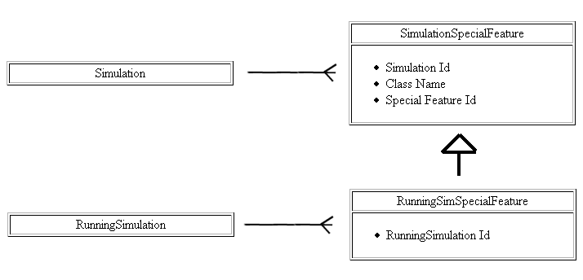
Figure 10. When a RunningSimulation is created for a particular Simulation, a copy of all of the Special Feagures is made for it.

Appendix A Design Considerations and Phased Development

Design Considerations
Below are our main considerations in the design of this software:

- Modular – to allow the transparent plugging in of new and improved modules. To accomplish this, programming will be done to interfaces and not to concrete objects. This will add to both programming time and processing time, but to accomplish what we are trying to do this is a necessary trade off.
- Web based play – The client programs of the players will communicate with the server via http or https.
- Completely Open Source – All modules not built by hand for this project can be freely distributed. A list of these is given in Appendix A.
- Platform Independent – Not discussed greatly in this document is the one thing greatly discussed in most Game Architecture documents; the display. Instead we are trying to create an underlying framework onto which any good display and input system can be added.
- Replay is essential – This is a training tool. A student or an instructor will need to be able to step back through the game and observe the choices made at each stage. This requirement forces us to save changes to the game as they occur, so the entire game can be replayed.
- No Money - This is an ambitious project. It is also an unfunded project. To ensure momentum along the way, we will need to create useful things along the way. Our development path will be roughly spiral with milestones that can be useful to people – whom we will then romance to get them to try this thing out so we can get valuable feedback.

Phased Development
Design consideration 6 – the advantage of having no money – leads us to specific development path. We will develop this program in three phases. Each of these is described below.

Phase I. We will enable simple ‘political science’ type simulations to be conducted via the Internet. These types of simulations have a long history of being done in one room or set of rooms by players working face to face. These simulations are completely ‘computer free’. Decisions about the outcomes of player actions are either determined arbitrarily or by the actions of other players. For example, “You did this, so I will do this.”

Generally in these games there is a ‘control’ player who runs the game and who arbitrates with regard to specific questions or events. For example, the control player could indicate that a player’s request for aid from Russia has been accepted or not.

Phase II. We will start replacing complete arbitrariness with machine decisions. Machine decisions are obviously not arbitrary free, but they are, at least, deterministic. Examples of a type of machine decision could be “You took those actions, so the formulas determine that the economy of your country grew 0.4% in the past month.”

Phase III. We will develop the ability to create completely AI driven scenarios. In a partially AI driven scenario, for example, the request for aid from the AI driven Chinese delegate could return the answer “No.” The control player could still play the role of actors that may or may not help. As our AI improves, the need for the control group, and indeed the entire network basis of the original game, may wither away.

Information forced on the player (as opposed to information requested from the player) is frequently referred to as an ‘inject.’ An inject is something that happens independent of player action, although player action may have lead to the conditions that created the inject. Example injects could be ‘terrorists strike Southern convey route’ or ‘season has now changed to summer.’
The right is reserved to take shortcuts occasionally - hopefully ones that can be refactored out later.
This is an ambitious goal, but one that keeps this interesting.

